Assignment:-4

Roll NO: 223203

Name: Sohel Mehbub Mulani

1:Create Student class with rollno,name address.

Write business logic for auto incrment of rollno(don't accept roll no from user)

Write parameterised constr for accepting name and address only

Write getter and setter and display function

1.1 Test Student class by creating 5 diff object.and display aal details(chk rollno created automatically)

1.2 Create an array of 5 students and show only names

1.3 modify 1.2 for showing students details who lives in Pune

**public** **class** Student {

**private** **static** **int** *rolno*;

**private** String name;

**private** String address;

**private** **int** rollno;

**static**

{

*rolno*=0;

}

**public** **void** assignStudent(String name,String address)

{

*rolno*++;

**this**.rollno=*rolno*;

**this**.name=name;

**this**.address=address;

}

**public** **void** displayStudent()

{

System.***out***.println("Roll No:"+rollno+"Name"+name+"Address:"+address);

}

**public** **void** setName(String name)

{

**this**.name=name;

}

**public** String getName()

{

**return** **this**.name;

}

**public** String getAddress()

{

**return** address;

}

}

**import** java.util.Scanner;

**public** **class** TestStudent {

**public** **static** **void** main(String[] args) {

// **TODO** Auto-generated method stub

Student[] arr=**new** Student[5];

**int** i,rollno;

Scanner sc=**new** Scanner(System.***in***);

System.***out***.println("Enter Student Name And Address ");

**for**(i=0;i<5;i++)

{

arr[i]=**new** Student();

arr[i].assignStudent(sc.next(), sc.next());

}

**for** (i=0;i<5;i++)

{

System.***out***.println("List of Student");

arr[i].displayStudent();

}

System.***out***.println("Whos Live in Pune Show Students Details:");

**for**(i=0;i<5;i++)

{

**if**(arr[i].getAddress().contentEquals("Pune"))

{

String a=arr[i].getAddress();

System.***out***.println(arr[i].getName());

}

}

}

}

OutPut:-

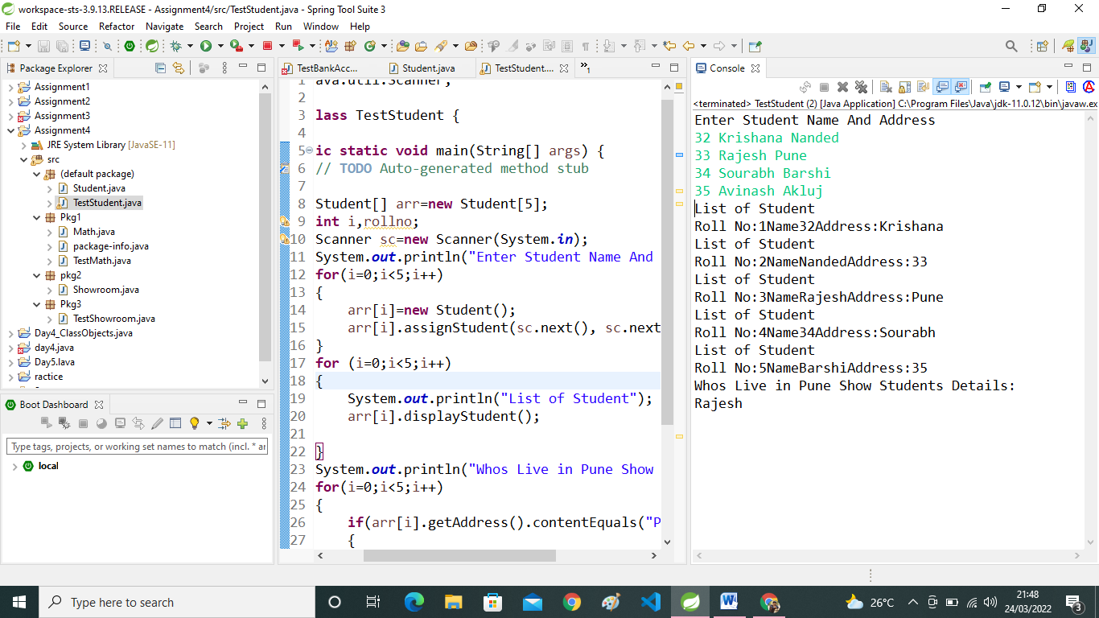

2:Create Math class for testing MethodOverloading Concept

Test it using tesrter class

**package** Pkg1;

**public** **class** Math {

**public** **static** **void** add(**int** a,**int** b)

{

System.***out***.println("Add a+b="+(a+b));

}

**public** **static** **void** add(**int** c,**double** d)

{

System.***out***.println("Add c+d="+(c+d));

}

**public** **static** **void** add(String e,String f)

{

System.***out***.println("Add e+f="+e+" "+f);

}

}

**package** Pkg1;

**public** **class** TestMath {

**public** **static** **void** main(String[] args) {

// **TODO** Auto-generated method stub

**int** a=10;

**int** b=20;

**int** c=30;

**double** d=40;

String e ="Pruthiviraj";

String f ="Howal";

Math.*add*(a, b);

Math.*add*(c, d);

Math.*add*(e,f);

}

}

OutPut:-

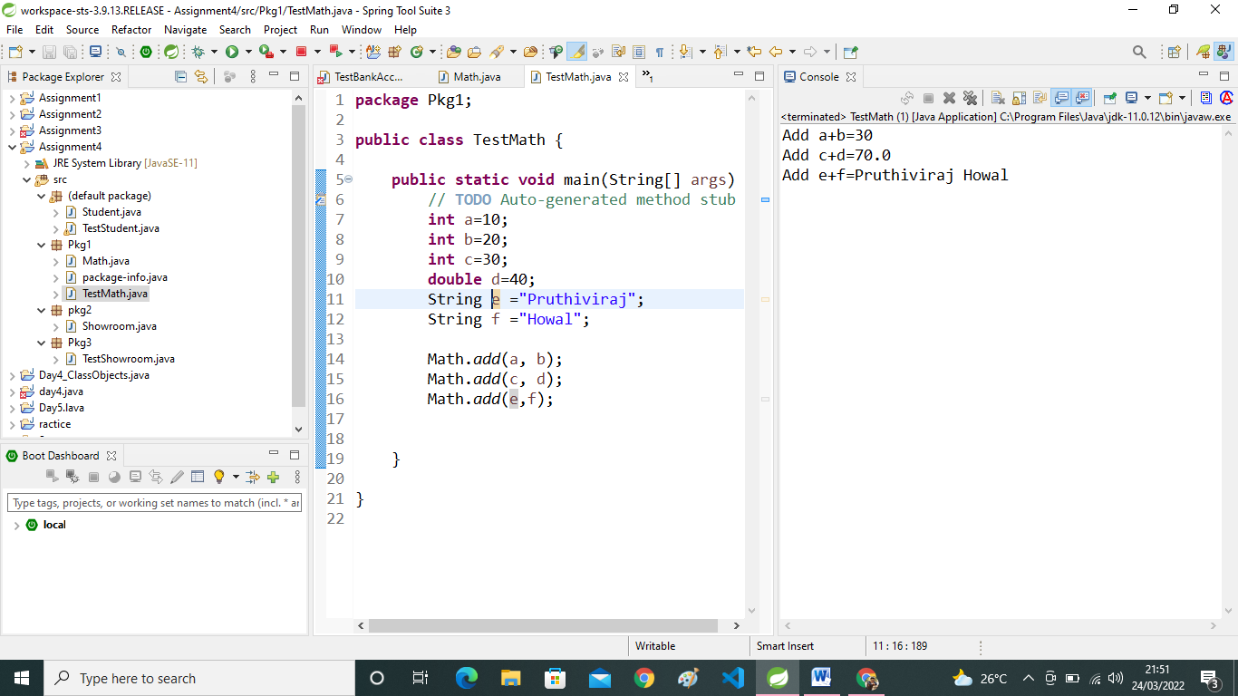

3:Create diff package and add class inside that.

Try to access one package class in another package....

(chk default access specifier)

**package** pkg2;

**public** **class** Showroom {

**public** **void** msg1()

{

System.***out***.println("This is Message Number One ");

}

**public** **void** msg2()

{

System.***out***.println("This is Message Number Two");

}

}

package Pkg3;

import Pkg1.Math;

import pkg2.Showroom;

public class TestShowroom {

public static void main(String[] args) {

// TODO Auto-generated method stub

Showroom s=new Showroom();

System.out.println("Below Messages From pkg2");

s.msg1();

s.msg2();

System.out.println("Below Messages From Pkg1");

int a=25;

int b=10;

Math.add(a, b);

}

}

OutPut:-

